SEG Dashboards

BRD

April 30, 2021

Introduction
This document describes the design of an interface, features and data components needed to display information about each area of store/district/region location level.
This document consists of two main 2 main parts.
- Dashboards
This part describes design of every single dashboard. Each dashboard description consists of the same headings:
  - Mockup
The Screenshot of each dashboard has been built using the components of the destined report platform. The final product will look exactly the same.
  - Permission
User Groups which has access to described dashboard.
  - Components
The description of every single component used on the dashboard (i.e. chart, dropdown etc.)
  - Description
The description of each component
    - Type – chart/dropdown etc.
    - Timeframe – period of time visible on the component
    - Color coding – HEX value of every color used on component
    - Redirect Type – Pop-up, drilldown
    - Redirect to – Target of redirect – page/dashboard etc.
- Pages
This part describes the design of page which will be stored in the application, used to preview data as a result of redirects.
  - Mockup
The Screenshot of each page has been built using components of the destined report platform. The final product will look exactly the same
  - Description

Store Dashboard

Mockup

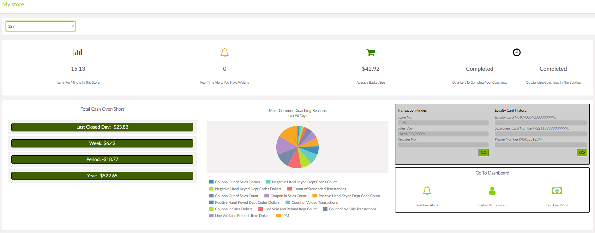

Permissions
Store Managers, District Managers, RVP

Description
Component | Type | Time Frame | Color Coding | Redirect Type | Redirect to
Store | Dropdown | N/A | N/A | N/A | N/A
Average Basket size | Top menu tile | last 5 financial weeks | F0AD4E | Pop-up | Basket size aggregations Page
Real time alerts | Top menu tile | All financial weeks | 337AB7 | Pop-up | Notification Module
Days left to complete coachings | Top menu tile | Current Financial week | D9534F | Pop-up | Cashier Coaching Landing Page
Cash over/short | Column chart | Yesterday, Week, Quarter, Year | FF0000,  0000FF,  FFA500,  207510 | Pop-up | Cash over shorts Dashboard (store/district/region level)
Items per minute | Top menu tile | Last financial week | 5CB85C | Pop-up | Cashiers by IPM Page
Link to Look up a loyalty card | Tile with link | N/A | N/A | Pop-up | Secure Store
Links to Search for a specific transaction | Tile with link | N/A | N/A | Pop-up | Secure Store
KPI Violations that triggered the most coaching | Column Chart | Last 30 days | 207510 | Pop-up | Coachings By KPI Page

District Dashboard

Mockup

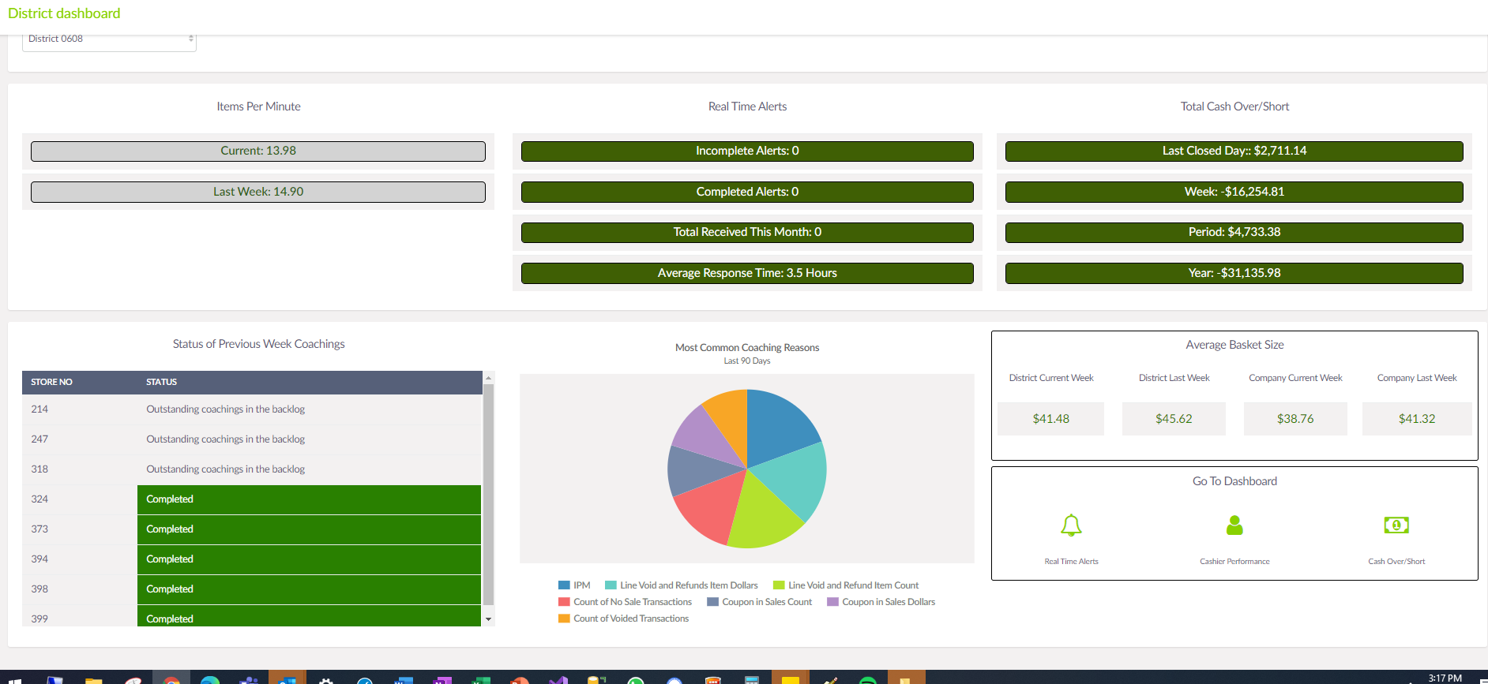

Permissions
District Managers, RVP

Description
Component | Type | TimeFrame | Color Coding | Redirect Type | Redirect to
District | Dropdown | N/A | N/A | N/A | N/A
Cash Over/Short (statistics by store) | column chart | Yesterday, Week, Quarter, Year | FF0000,  0000FF,  FFA500,  207510 | Pop-up | Store Dashboard
Average Items per minute (Store averages) | column chart | last financial week | 207510,  FF0000 | Pop-up | Store Dashboard
TOP 5 Cashier Coaching Compliance | Column chart | Last financial week | 207510 | Pop-up | Store Dashboard
Real time alerts (district completion percentages) | pie chart | Last financial week | 0072A4,  028181 | Pop-up | Real Time Alerts Dashboard

RVP Dashboard

Mockup

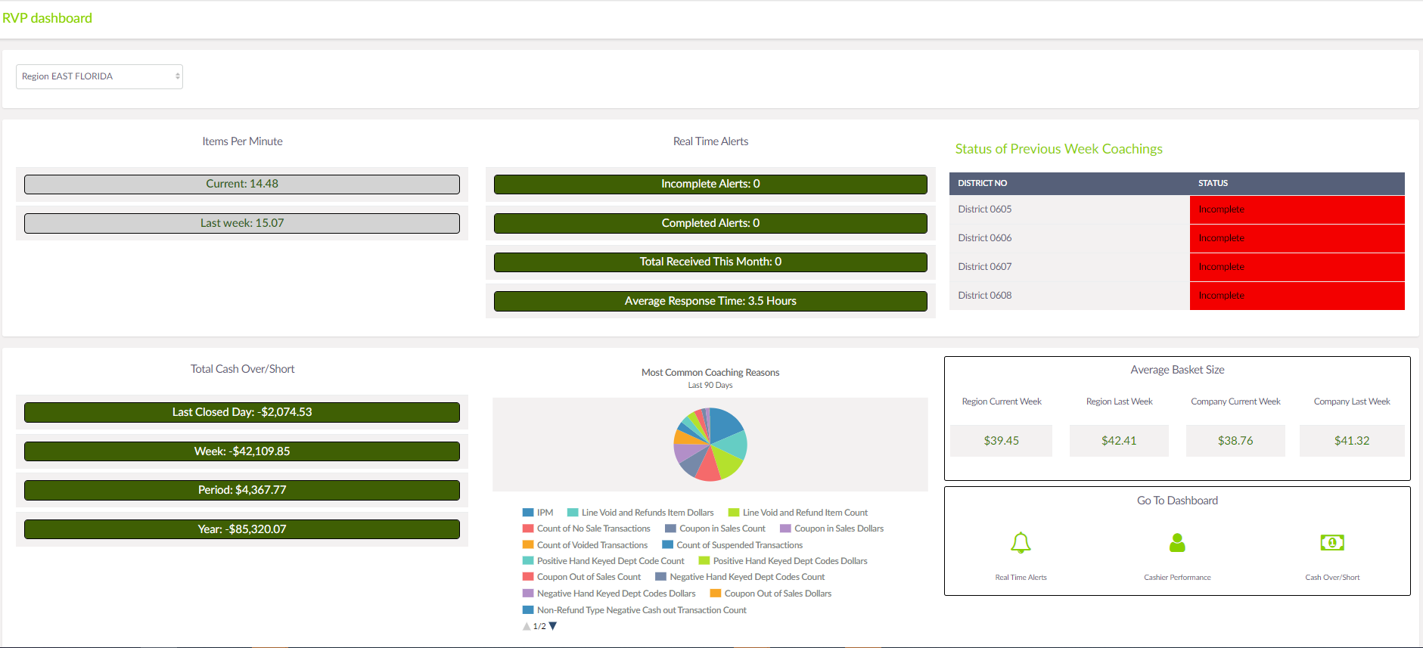 Permissions
RVP

Description
Component | Type | TimeFrame | Color Coding | Redirect Type | Redirect to
Level | Dropdown | N/A | N/A | N/A | N/A
Location | Dropdown | N/A | N/A | N/A | N/A
Coaching compliance in current financial week (by district) | Pie chart | Current Financial week | 0072A4,  028181 | Pop-up | Cashier Coaching Landing Page
Cash Over/Short | Column chart | Yestarday,Week,Quarter,  Year | FF0000,  0000FF,  FFA500,  207510 | N/A | N/A

Cash over shorts Dashboard (store/district/region level)

Mockup

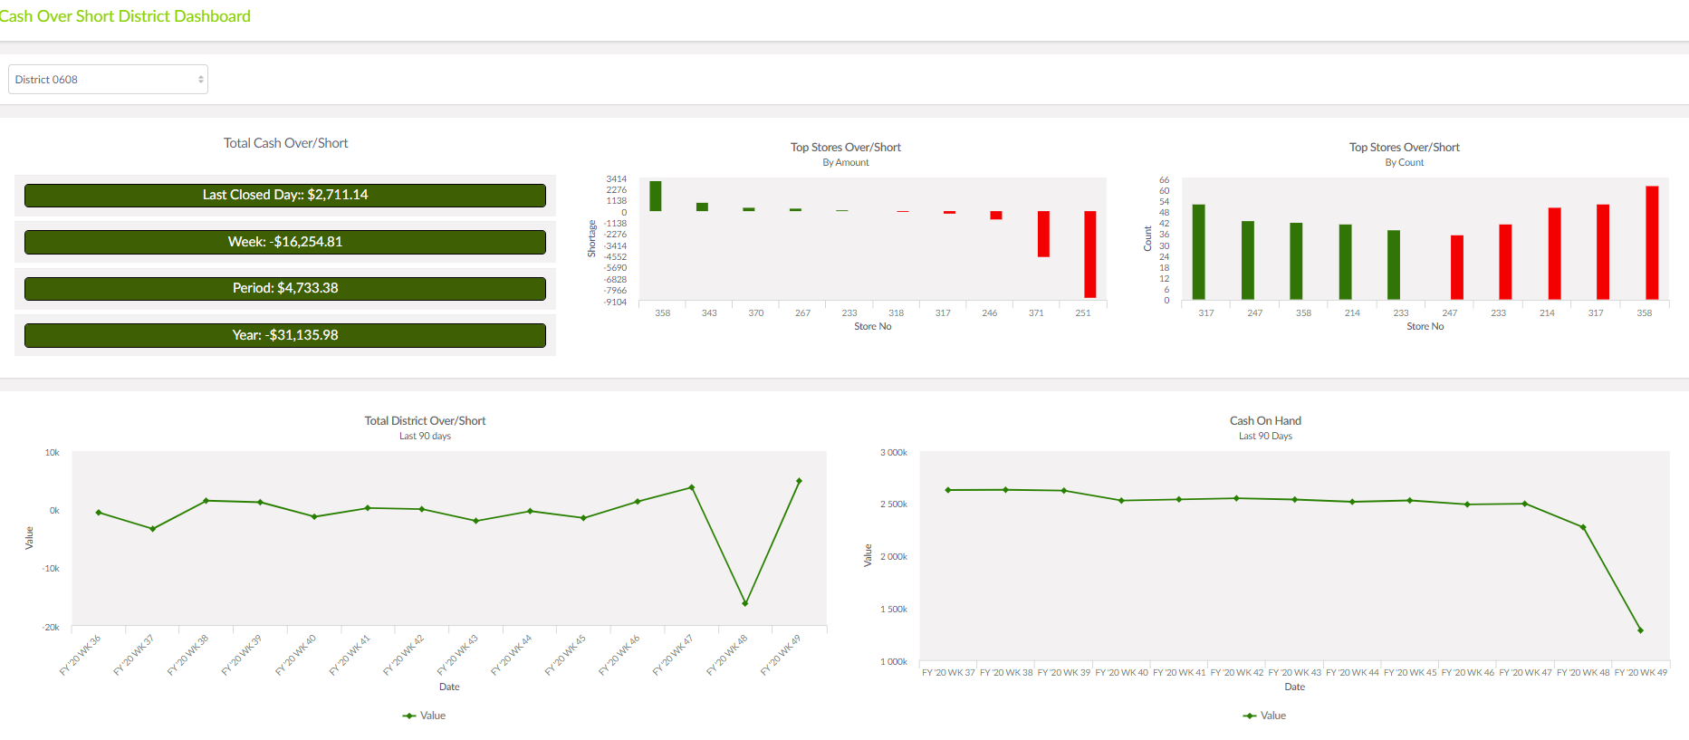

Permissions
Store Managers, District Managers, RVP

Description
Component | Type | TimeFrame | Color Coding | Redirect Type | Redirect To
Level | Dropdown | N/A | N/A | N/A | N/A
Location | Dropdown | N/A | N/A | N/A | N/A
Safe totals | Column Chart | Yestarday,Week,  Quarter,Year | FF0000,  0000FF,  FFA500,  207510 | N/A | N/A
Top Cashiers Over/Short | Column Chart | last 30 days | 207510 | N/A | N/A
Store Over/Short | Column Chart | last 30 days | 207510 | Drilldown | Secure Store – Single Store Report
Cash on Hand | Line Chart | last 30 days | 207510 | N/A | N/A

Cashier Performance Dashboard (store/district/region level)

Mockup

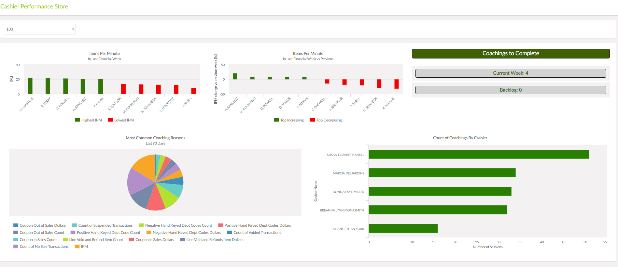

Permissions
Store Managers, District Managers, RVP

Description
Component | Type | TimeFrame | Color Coding | Redirect Type | Redirect to
Level | Dropdown | N/A | N/A | N/A | N/A
Location | Dropdown | N/A | N/A | N/A | N/A
Item per minute | Column chart | last financial week | 207510 | Pop-up | Cashiers by IPM Page
Item per minute (by percentage increased / decreased) | Column chart | Last financial week versus previous financial week compliance | 207510 | Pop-up | Cashiers by IPM Page
Backlog tracking | Bar chart | Last 30 days. | 207510,  FF0000 | Pop-up | Backlog training page
KPI Violations that triggered the most coachings | Pie chart | Last 30 Days. | 0072A4,  028181 | Pop-up | Coachings by KPI Page
Cashiers with most coachings sessions | Bar chart | Last 30 Days | 207510,  FF0000 | Pop-up | Previous coachings Page

Average respond time by Manager Page
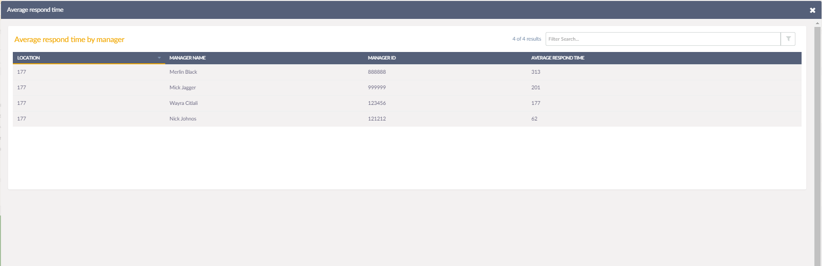
Page with Search Grid Result showing average respond time on alerts for specified manager, store.

Previous coachings Page
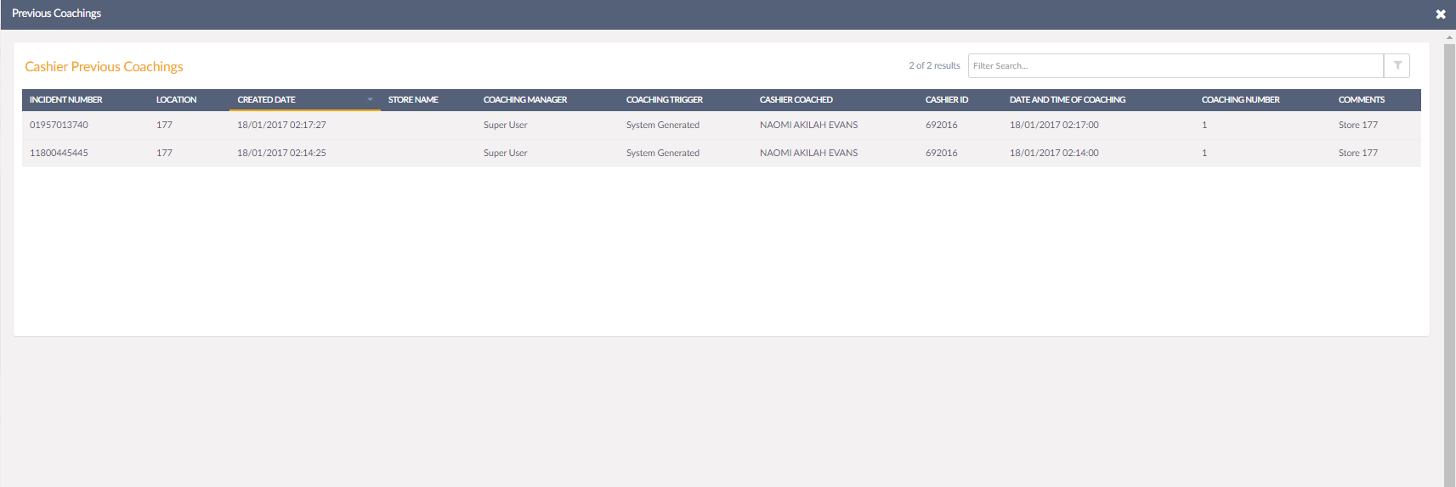
Page with Search Grid Result showing previous coachings for specified cashier.

Coachings by KPI Page
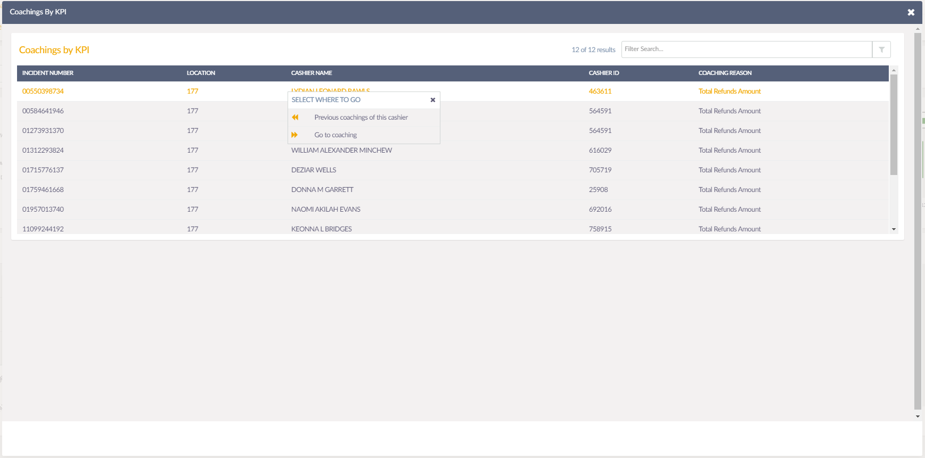

Page with Search Grid Result showing coachings for KPI triggered. When clicking on the row, pop-up appears with two possible further drilldowns. Previous coachings Page (12) and Coaching.

Real Time Alerts by Cashiers Page
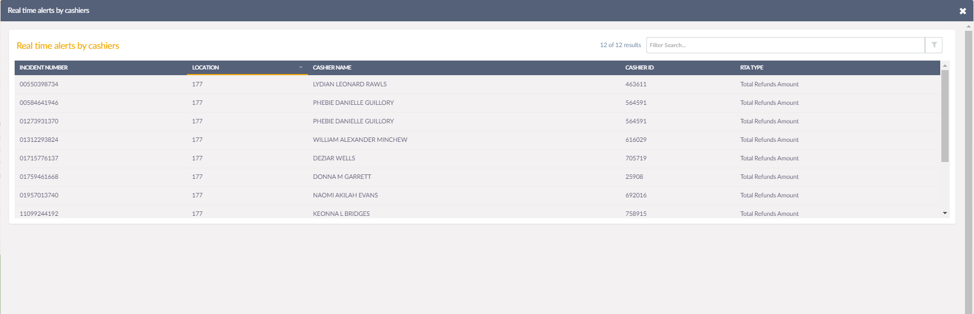
Page with Search Grid Result showing raised alerts for cashiers for specified Store.

Basket size aggregations Page
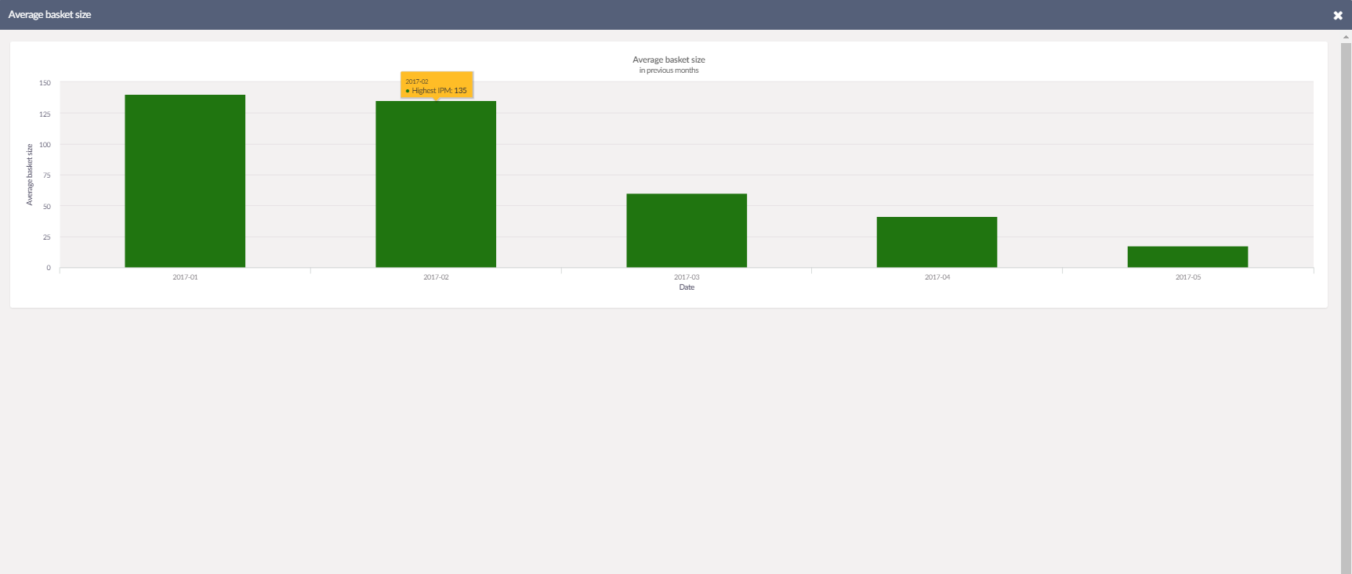
Page with column chart showing average basket size in a store for last 5 days.

Cashiers by IPM Page
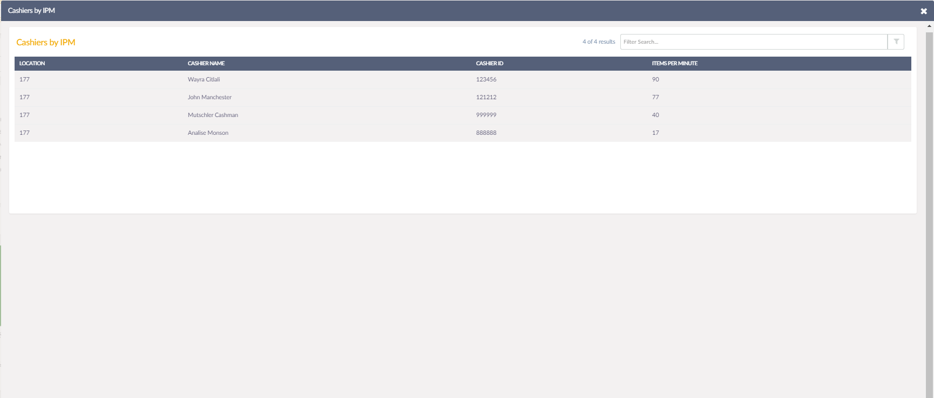
Page with Search Grid Result showing IPM value for all cashiers within specified store.

Cashier Coaching Landing Page
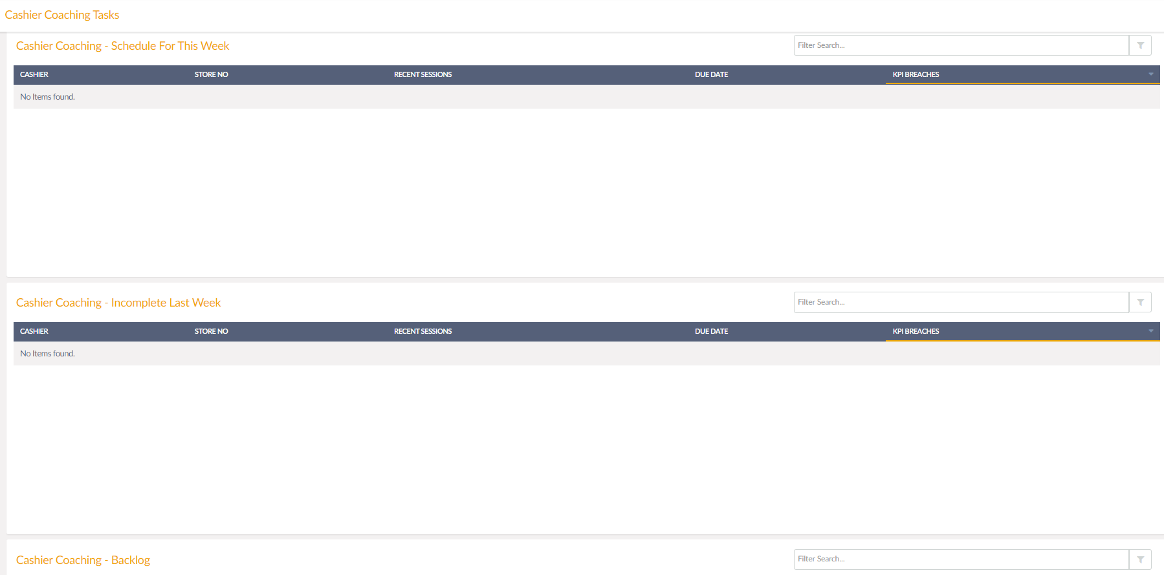
Page already exists in the system. It shows coachings coachings scheduled for the current period, last week, and backlog.

Backlog training page
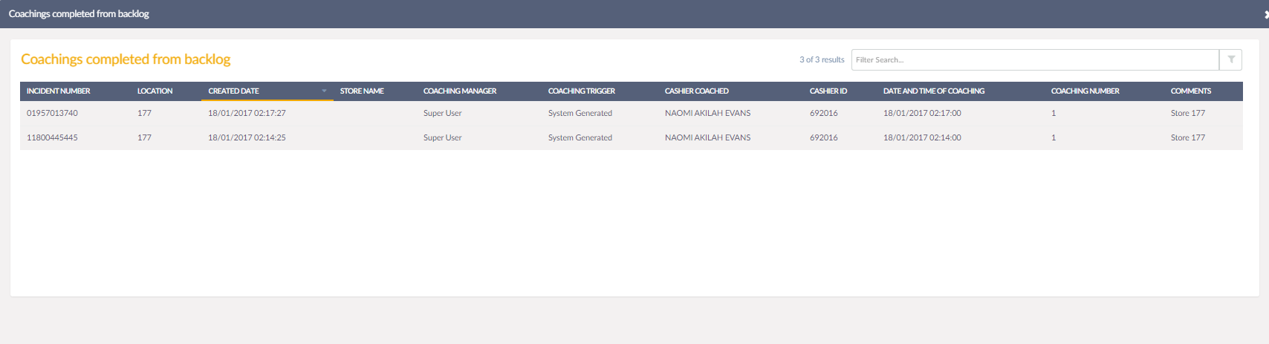

Page with Search Grid Result showing coachings completed from backlog.

